CLOUD SECURITY PROJECT
Firewall configuration, access control, virtual machine creation, risk detection in Google Cloud Platform
Author: Żuchowski Norbert
Role: Cloud Security / Cybersecurity Engineer
Platform: Google Cloud Platform (GCP)
Scope: Compute Engine, IAM, VPC, Firewall, Cloud Storage, Logging & Monitoring, Security Best Practices

Summary of the work done
The aim of the project was to identify and analyze weaknesses in cloud architecture that could pose a real threat to the company's resources. To this end, the Google Cloud environment configuration was reviewed and security measures were implemented. As part of this work, Network Firewall policies were configured and updated, isolating and neutralizing potentially unsafe services. A new VM was also created in Compute Engine, based on a backup of an existing instance that was found to have non-compliance with applicable security standards and best practices. A key element of the analysis was the use of the Security Command Center, where a risk review was carried out and the configuration compliance with security requirements was verified. Additionally, Cloud Storage settings were analyzed, identifying potential issues with buckets and data access. The introduced actions have significantly increased the level of environmental security, enabling the elimination of detected threats, limiting the risk of attack and ensuring compliance with accepted security standards.

Project objectives
• Build a secure infrastructure in GCP
• Configure access control according to the Least Privilege principle
• Securing VM instances
• Implementation of firewalls and segmentation
• Enabling logging, monitoring and alerts
• Performing a performance test and configuration validation
Risk analysis
After applying the appropriate filters, the system showed three high-risk hazards. They are related to the bucket, firewall and computing unit.
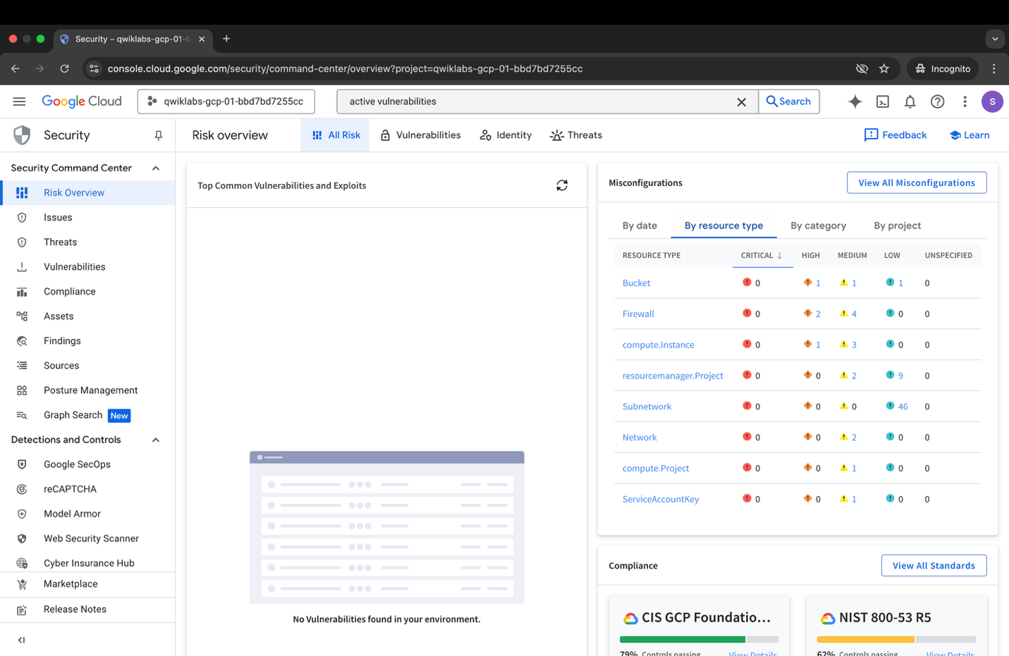

Next, the specific problems related to the above categories are analyzed. You can notice that both the RDP and SSH ports are open, which makes remote access from the outside allowed.
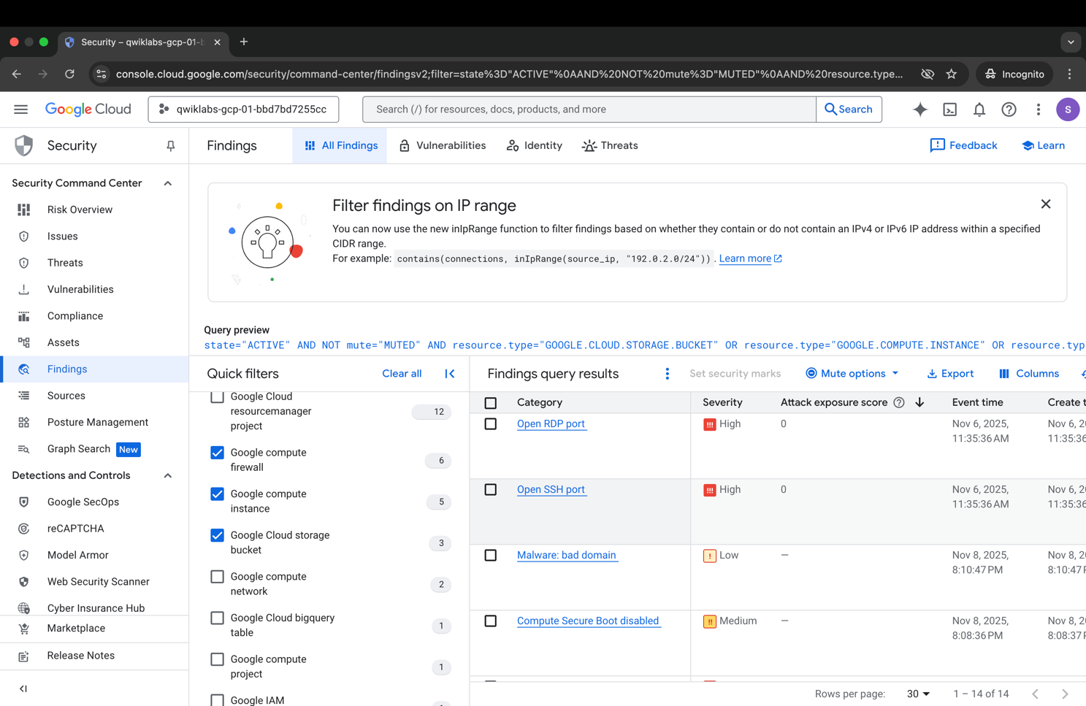

The following table classifies the weaknesses found.
Id | Risk | Level | Proof | Constraint
R-01 | Open SSH and RDP port | High | SCC Finding / Firewall rules | Firewall Lock, VM Isolation
R-02 | Public bucket (allUsers) | Critical | Screenshot | Remove public access
R-03 | Non-compliant VM | High | SCC Report | Snapshot

First, the unsecured machine was stopped to prevent it from connecting to it, restricting access to resources for unwanted people.

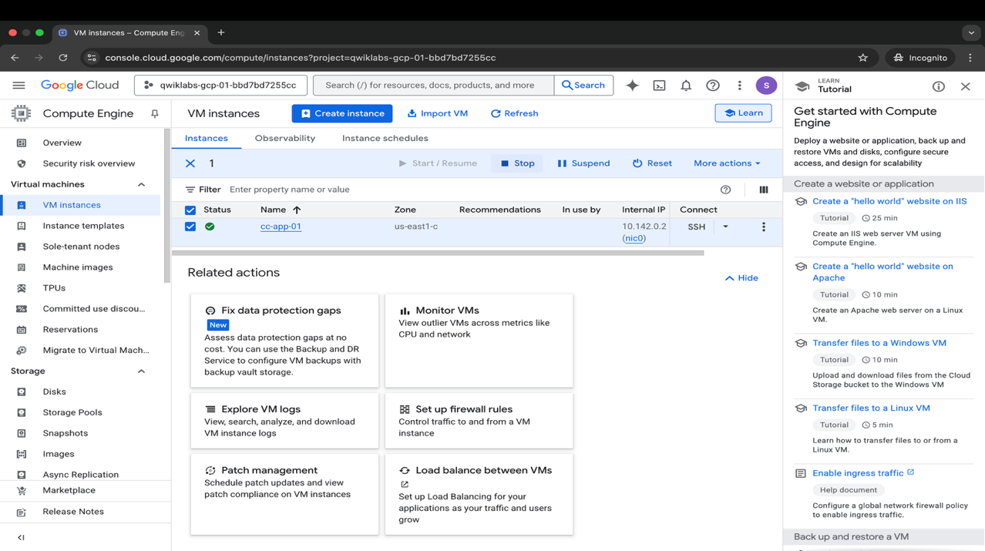
Then a new virtual machine was created with a startup disk with the last backup of the cc-app-01 machine
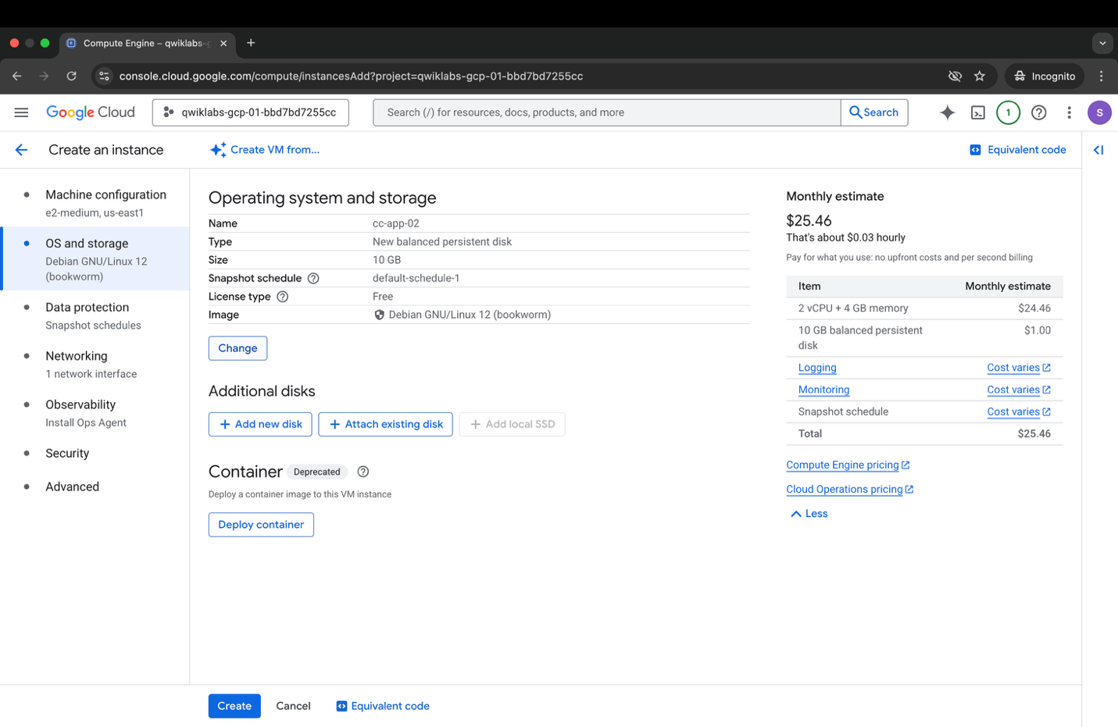

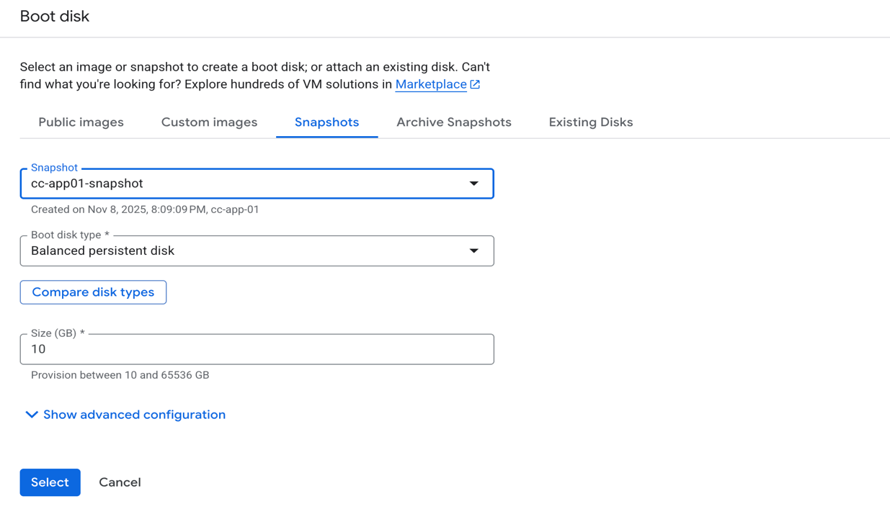
The following screenshot shows the new VM and configuration running.
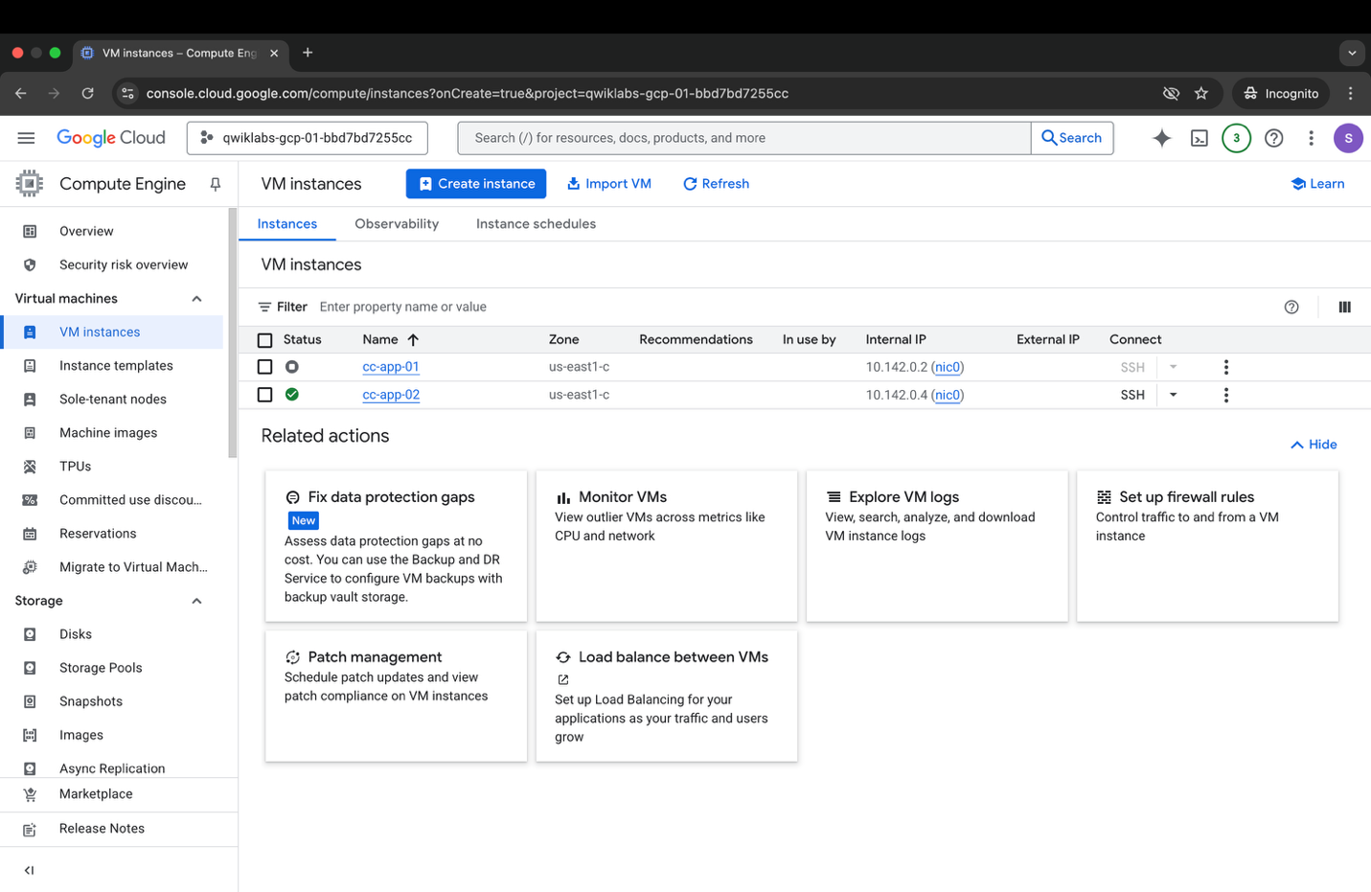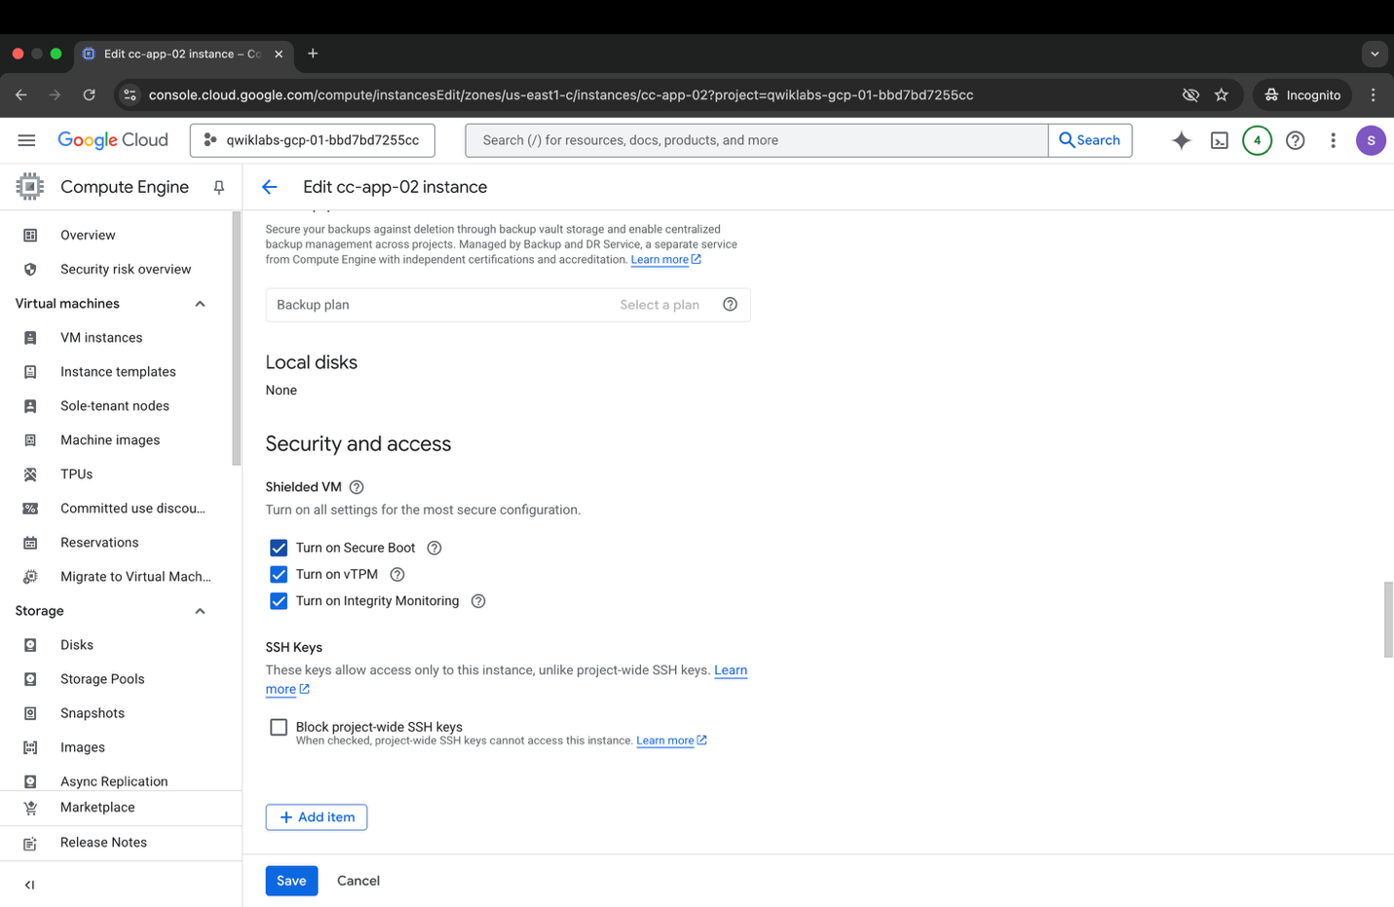
Confirmed the correct creation and operation of the cc-app-02 machine and removed the cc-app-01 machine
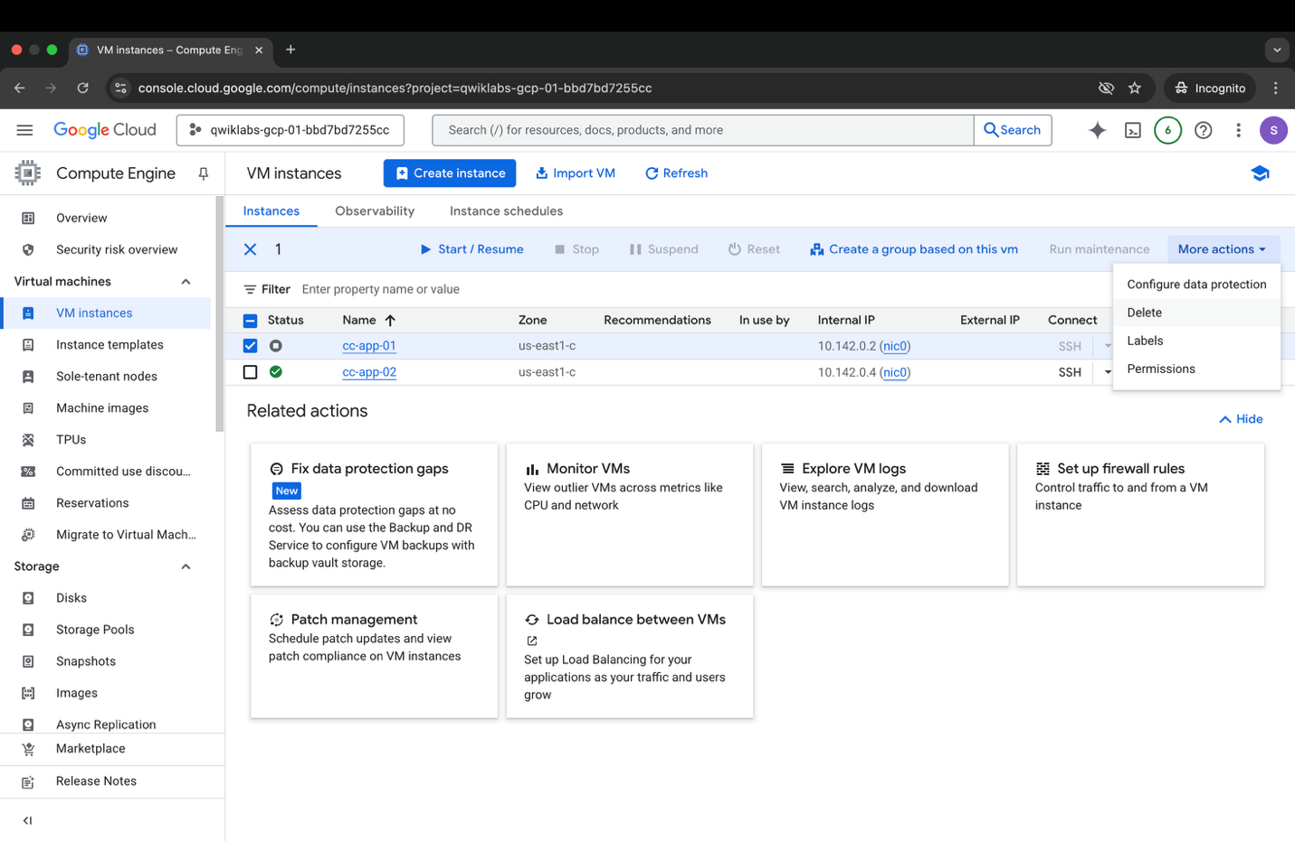
In the next step, the container where the data stored in the cloud is located was analyzed. It can be seen that all users using the Internet have access to it, which is a very big risk. Access has been updated and limited to users who need access to it to perform their work duties.

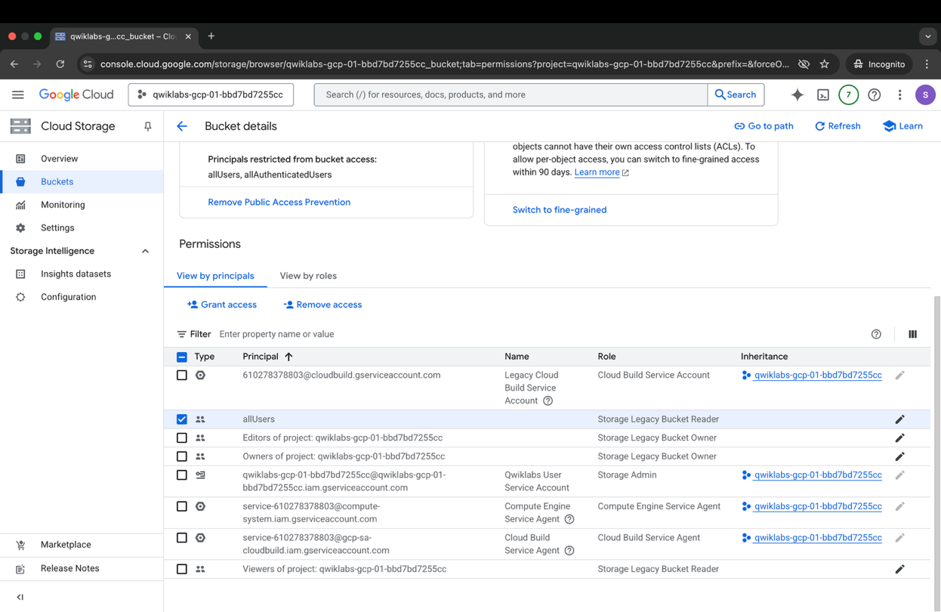

The last step was to configure the firewall properly. By disabling the default access to RDP, SSH, and IMCP.
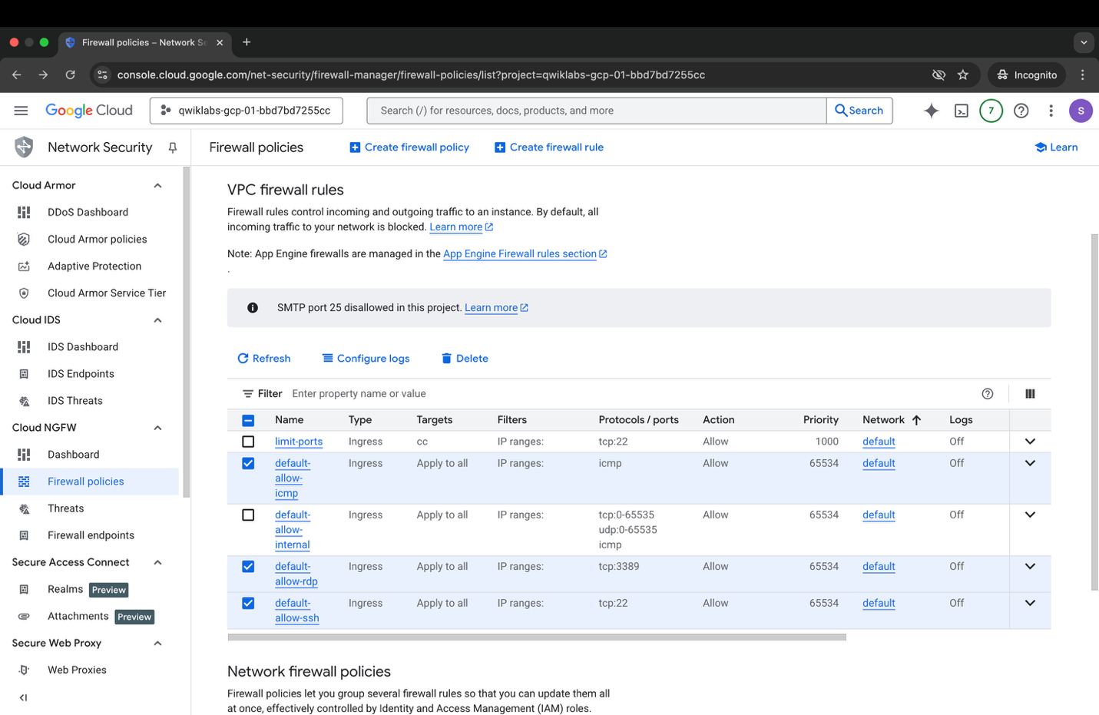
Conclusions and results
The environment meets the basic security requirements as recommended by Google Cloud Security Foundations. Key risks have been reduced and exposure to the Internet has been reduced. The following table documents the differences in the condition before and after.

Area | BEFORE | Status of the PO
VM instances | VM cc-app-01 active, with open SSH and RDP ports accessible from the Internet | Risky VM stopped and isolated; snapshot taken and a new standards-compliant cc-app-02 instance created
Network / Firewall | Global firewall rules allowed traffic from 0.0.0.0/0, including SSH, RDP, ICMP | Blocked administrative ports, implemented a deny all inbound policy, allowing only operationally required traffic
Cloud Storage (Bucket) | Public bucket shared with allUsers | Removed the allUsers role, implemented the principle of minimum permissions, access only for eligible roles/projects
IAM / Access Control | Lack of full control of permissions, broad roles, lack of least privilege | Permissions have been narrowed, roles consistent with functions have been assigned; Storage and Compute access limited
Network segmentation | Non-segregated environment | Basic segmentation and separation of the risky instance from the rest of the environment
Security Command Center | SCC showed High-Risk Findings (public bucket, open ports, non-compliance) | All relevant alerts resolved: ports closed, bucket secured, VM replaced
Monitoring / Logging | Lack of full observability at risk and compliance level | Enabled SCC analysis, logs, monitoring for new resources
Backup | No recovery process; snapshots were not used | Snapshot taken, new VM restored from a valid backup

